

**MINI PROJECT REPORT**

**ON**

## Travel & Tourism Management System

**BY**

**Name Roll No**

**Rahul Nair 22073**

**Course: MCA I Sem.: I**

**PRATIBHA INSTITUTE OF BUSINESS MANAGEMENT CHINCHWAD, PUNE-411019**

**2022-2023**



# CERTIFICATE

This is to certify that the Project “Travel & Tourism Management System”

Submitted by Rahul Nair 22073

is a bonafide work carried out by Students under the supervision of Prof. **Rajnish Mishra** and it is submitted towards the partial fulfillment of the requirement of Master of Computer Applications Department.

### Prof.Rajnish Mishra Prof. Manish Patankar Project Guide Head of Department (MCA)

Internal Examiner External Examiner

# Acknowledgments

It gives us great pleasure in presenting the preliminary project report on

‘**Travel & Tourism Management System**’.

I would like to take this opportunity to thank my internal guide **Prof. Rajnish Mishra** for giving me all the help and guidance I needed. I am grateful to them for their kind support. Their valuable suggestions were very helpful.

I am also grateful to **Prof. Manish Patankar**, Head of MCA Department, Pratibha Institute of Business Management for his indispensable support, suggestions.

In the end our special thanks to other Team Members for providing various resources such as laboratory with all needed software platforms, continuous Internet connection, for Our Project.

### Student Name Roll No

**Rahul Nair 22073**

**Index**

|  |  |
| --- | --- |
| **Chapter** | **Page number** |
| **CHAPTER 1 : INTRODUCTION** | |
| 1.1 Existing System |  |
| 1.2 Need for System |  |
| 1.3 Operating Environment Hardware and Software |  |
| **CHAPTER 2 : PROPOSED SYSTEM** | |
| 2.1 Proposed System (Introduction of system) |  |
| 2.2 Module specifications (Scope) |  |
| 2.3 Objectives of System |  |
| **CHAPTER 3 : ANALYSIS & DESIGN** | |
| 3.1 Use Case Diagrams |  |
| 3.2 Activity Diagram |  |
| 3.3 Class Diagram |  |
| 3.3 Module Hierarchy Diagram |  |
| 3.4 Table specifications (Database design) |  |
| 3.5 Data dictionary |  |
| **CHAPTER 4 : USER MANUAL** | |
| 4.1 User Interface Screens (Input) |  |
| 4.2 Output Screens with data |  |
| 4.3 Data Reports |  |
| 4.4 Sample program code |  |
| 4.5 Limitations and Bibliography |  |

#### CHAPTER 1 : INTRODUCTION

* 1. **Existing System**

In the existing system, each task is carried out manually and processing is also a tedious job. In previous system travellers were maintaining time table details manually in pen and paper, which was time taking and costly. The travellers is not able to achieve its need in time and also the results may not accurate. Because of the manual maintenance there are number of difficulties and drawbacks exist in the system.

Some of them are Drawbacks of the Existing System:

* Increased transaction leads to increased source document and hence maintenance becomes difficult.
* If any admin, user entry is wrongly made then the maintenance becomes very difficult.

#### Need for System

The proposed system is designed to be more efficient than the manual system. It invokes all base tasks that are now carried out manually, such as the forms transactions and reports which is added advantage. The proposed System is completely computer-based application. Thousands of records can search and displayed without taking any significant time

Advantages of the Proposed System:

* + - Gives accurate information
    - Simplifies the manual work
    - It minimizes the documentation related work
    - Provides up to date information
    - Friendly Environment by providing warning messages.
    - travellers’ details can be provided
    - booking confirmation notification

#### Operating Environment Hardware and Software

**1.1 At Server Side:**

#### Hardware Configuration (Minimum Requirements)

|  |  |
| --- | --- |
| Name | Details |
| Processor | i3 Generation & above |

|  |  |
| --- | --- |
| RAM | 4GB & above |
| Hard Drive | 500 GB & Above |

**Software Environment (Minimum Requirements)**

|  |  |
| --- | --- |
| Name | Details |
| Operating System | Windows 10 & above |
| Database Sever | MYSQL |
| Web Server | JDBC |
| Browser | Chrome Browser |
| Framework | Java Swing & AWT |
| IDE | NetBeans |

#### CHAPTER 2: PROPOSED SYSTEM

* 1. **Proposed System (Introduction of system)**

Travel and tourism management system is used to book a tour from anywhere in the world by a single dynamic website which will help the user to know all about the places and tour details in a single website.

The admin can add packages to the website from a certain travel agents and hotels by create a tour page. Then the users can sign in and book each project, they can be confirmed by the admin in them manage booking page. The user can see the confirmation in my booking page.

It is a easiest platform for all travellers which can be easily booked and know the all details. Tour Management system is a dynamic website for tourism business. It is dynamic and responsive web design. It is also called travel technology solution for agencies & tour operation. Nearly Everyone goes on a vacation for this ‘a Tourism management system’ would play a vital role in planning the perfect trip.

The tourism management system allows the user of the system access all the details such as location, events, etc. The main purpose is to help tourism companies to manage customer and hotels etc. The system can also be used for both professional and business trips

#### Module specifications (Scope)

1. Admin authentication: This module is mainly based on admin. System will check the admin username and password for authentication. After the verification for authorization the admin can be able to precede the process. All works are done under his control.
2. User Registration: This module covers the details about the registration of users which they can be register by itself by adding data like name, password, email id and further details. After registration they can be sign in by their username and password.
3. Package Creation: The admin can create packages by creating package page which the type, price, details, place details all the travel tour package details can be added here. Which it will be showed in user homepage.
4. Package booking: in this module maintain the booking of travel packages by the user by selecting a various package with date and certain comments.
5. Booking confirmation/manage: Booking confirmation is the process of confirming the booked packages by the admin that is booked by the user with date and comment. Also, admin can manage the booking by cancelling.
6. Issue ticket: Tickets can be issued for the user in the issue ticket page in the homepage of user the certain booked packages only can be issued.

#### Objectives of System

System design is the process of defining the elements of a system such as the architecture, modules and components, the different interfaces of those components and the data that goes through that system. It is meant to satisfy specific needs and requirements of a business or organization through the engineering of a coherent and well-running system.

System designing in terms of software engineering has its own value and importance in the system development process. To mention it may though seem as simple as anything or simply the design of systems, but in a broader sense it implies a systematic and rigorous approach to design such a system which fulfils all the practical aspects including flexibility, efficiency, and security.

Before there is any further discussion of system design, it is important that some points be made clear. As it goes without saying that nothing is created that is not affected by the world in which it’s made. So, the systems are not created in a vacuum.

They are created to meet the needs of the users. They are not only intended to solve the existing problems, but they also come up with acceptable solutions to the problems that may arise in the future. The whole process of system development, from blueprint to the actual product, involves considering all the relevant factors and taking the required specifications and creating a useful system based on strong technical, analytical and development skills of the professionals.

Let’s get back to our discussion about what the system design phase is and the importance of system design in the process of system development. Being another important step in the system development process, system designing phase commences after the system analysis phase is completed. It’s appropriate to mention that the output or the specifications taken through the phase of system analysis become an input in the system design phase which in turn leads to workout based on the user defined estimations.

The importance of this phase may be understood by reason of the fact that it involves identifying data sources, the nature and type of data that is available. For example, to design a

salary system, there is a need for using inputs, such as, attendance, leave details, additions or deductions etc. This facilitates understanding what kind of data is available and by whom it is supplied to the system so that the system may be designed considering all the relevant factors. In addition, system designing leads to ensure that the system is created in such a way that it fulfils the need of the users and keep them at ease being user oriented.

#### CHAPTER 3: ANALYSIS & DESIGN

* 1. **Use Case Diagrams**

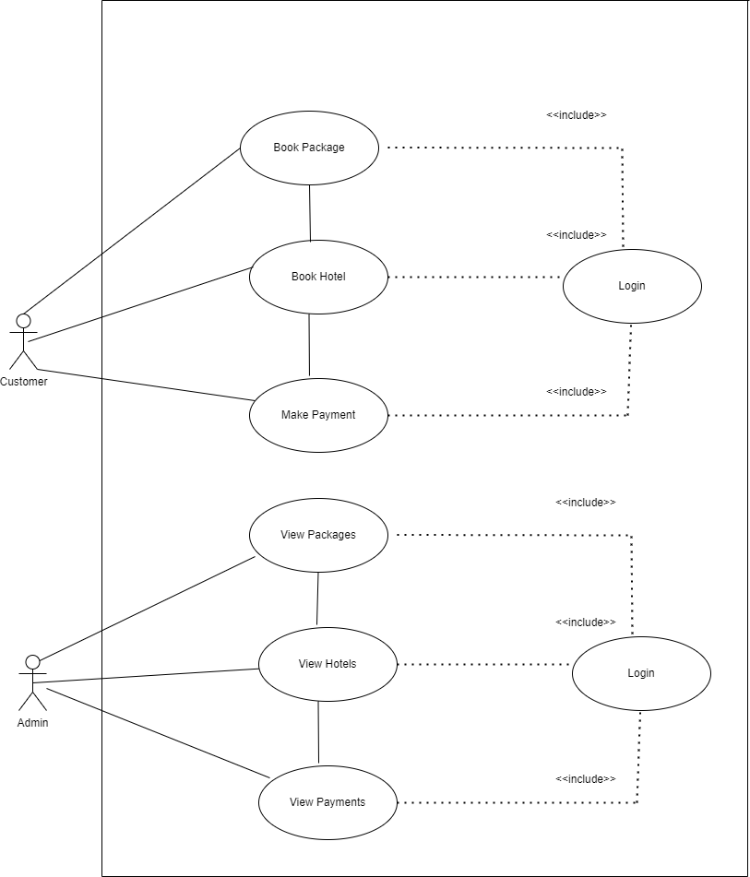

#### Class Diagram

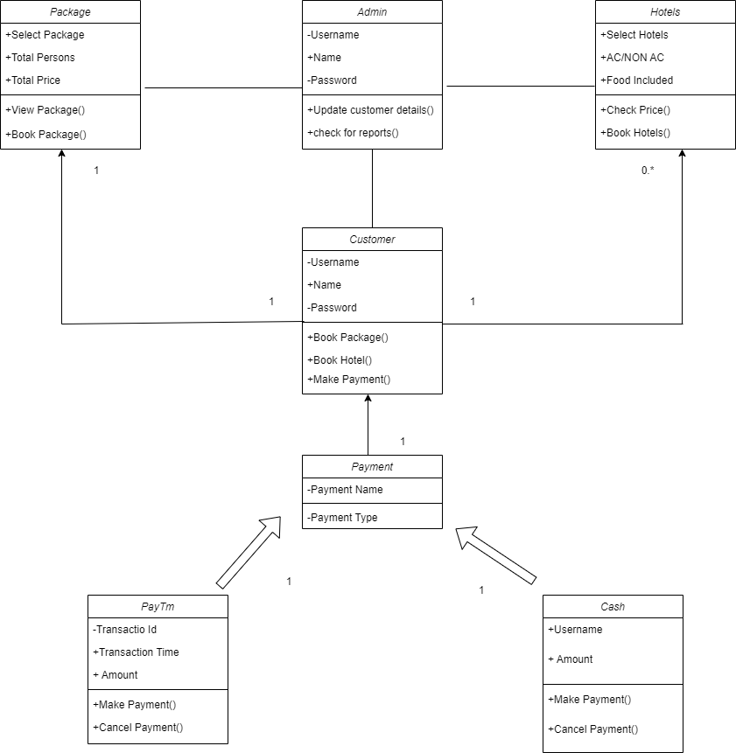

* 1. **Sequence Diagram**

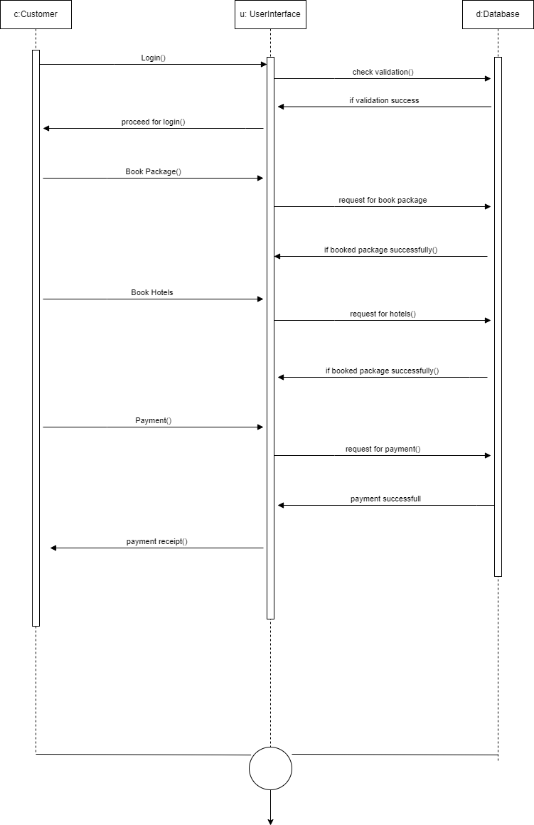

* 1. **Activity Diagram**

Activity Diagram

Select Tour Package

Request Scheme



New Customer

Register Customers

New Tour Information

Make Payment

Reserve Tour

**3.4 Table specifications (Database design)**

**TABLE 3.4.1: ACCOUNT:**

|  |  |  |  |  |
| --- | --- | --- | --- | --- |
| **Field** | **Type** | **Null** | **Key** | **Default** |
| username | varchar(30) | NO | PRI | NULL |
| Name | varchar(30) | NO | PRI | NULL |
| password | varchar(30) | NO |  | NULL |
| security | varchar(30) | NO |  | NULL |
| Answer | varchar(30) | NO |  | NULL |

**TABLE 3.4.2: CUSTOMER:**

|  |  |  |  |  |
| --- | --- | --- | --- | --- |
| **Field** | **Type** | **Null** | **Key** | **Default** |
| username | varchar(30) | NO | MUL | NULL |
| id | varchar(30) | NO | PRI | NULL |
| id_number | varchar(30) | NO |  | NULL |
| name | varchar(30) | NO |  | NULL |
| gender | varchar(30) | NO |  | NULL |
| country | varchar(30) | NO |  | NULL |
| address | varchar(30) | NO |  | NULL |
| phone | varchar(30) | NO |  | NULL |
| email | varchar(30) | NO |  | NULL |

**TABLE 3.4.3: BOOK PACKAGE:**

|  |  |  |  |  |
| --- | --- | --- | --- | --- |
| **Field** | **Type** | **Null** | **Key** | **Default** |
| username | varchar(30) | NO | MUL | NULL |
| package | varchar(30) | NO |  | NULL |
| persons | int(10) | NO |  | NULL |
| id | varchar(30) | NO | MUL | NULL |
| id_number | varchar(30) | NO |  | NULL |
| phone | varchar(30) | NO | PRI | NULL |
| price | varchar(30) | NO |  | NULL |

**TABLE 3.4.1: Hotel:**

|  |  |  |
| --- | --- | --- |
| **Field** | **Type** | **Null** |
| name | varchar(30) | NO |
| costperday | varchar(30) | NO |
| foodcharges | varchar(30) | NO |
| Ac charges | varchar(30) | NO |
| Answer | varchar(30) | NO |

**TABLE 3.4.2:: Book Hotel**

|  |  |  |  |
| --- | --- | --- | --- |
| **Field** | **Type** | **Null** | **Key** |
| username | varchar(30) | NO |  |
| Hotel Name | varchar(30) | NO | PRI |
| Total Persons | varchar(30) | NO |  |
| No of days | number(10) | NO |  |
| Ac/ Non Ac | varchar(30) | NO |  |
| Food | varchar(30) | NO |  |
| ID | varchar(30) | NO |  |
| phone | number(10) | NO |  |
| email | varchar(30) | NO |  |

**TABLE 3.4.3:Cash Payment:**

|  |  |  |  |
| --- | --- | --- | --- |
| **Field** | **Type** | **Null** | **Key** |
| username | varchar(30) | NO |  |
| amount | Number(10) | NO |  |

**CHAPTER 4: USER MANUAL**

* 1. 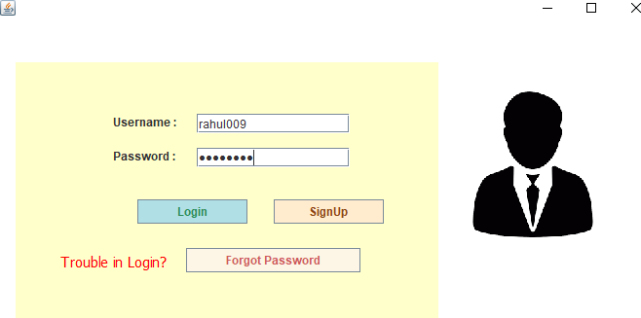**User Interface Screens (Input) Login Page**

**Loading Page:**

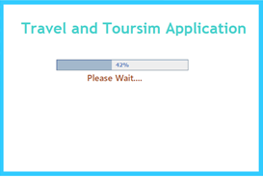

**Main Frame:**

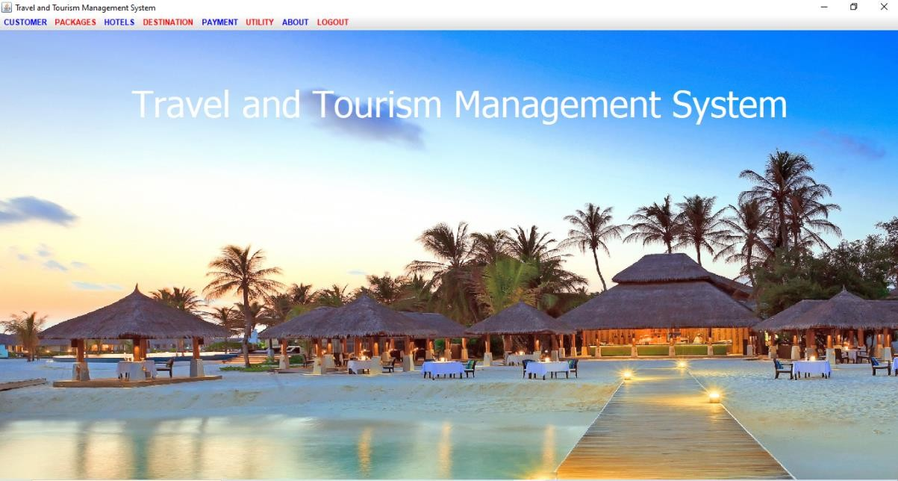

**Personal Details:**

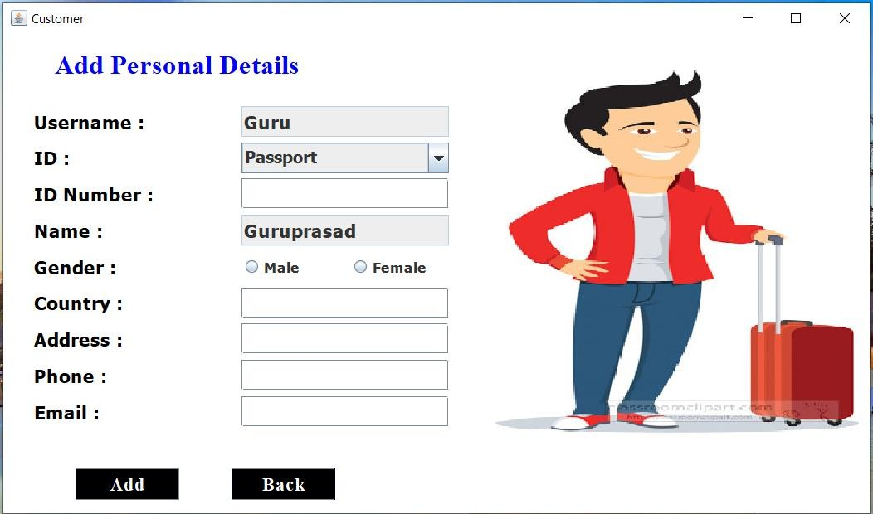

**UPDATE CUSTOMER PAGE:**

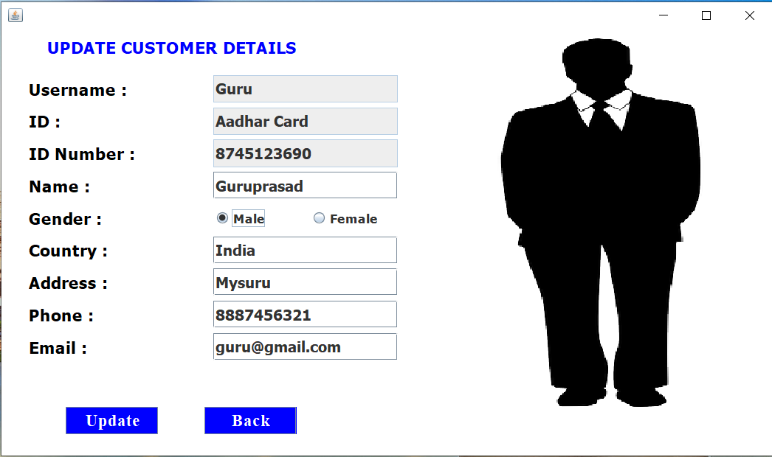

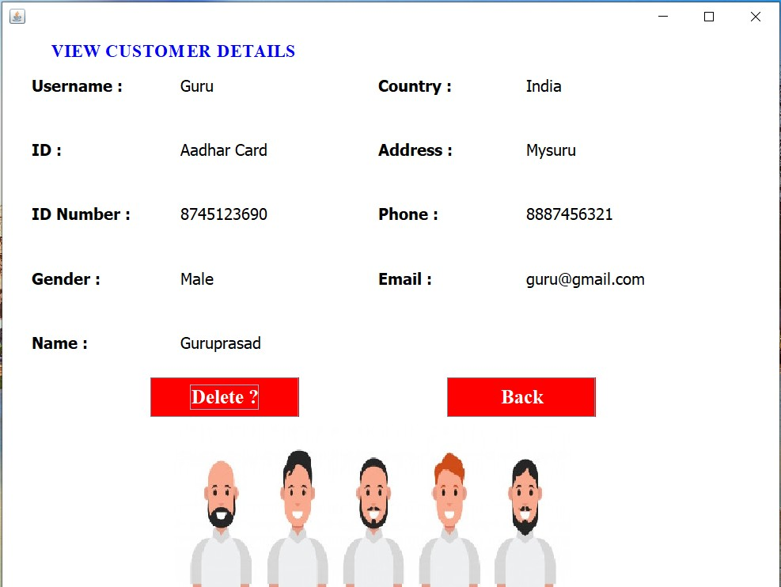**View Customer Page:**

**Package Page:**

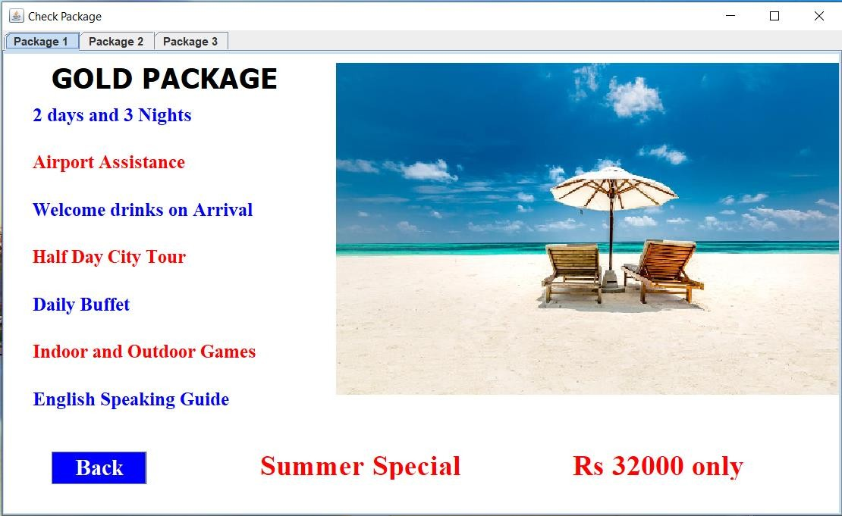

**Book Package:**

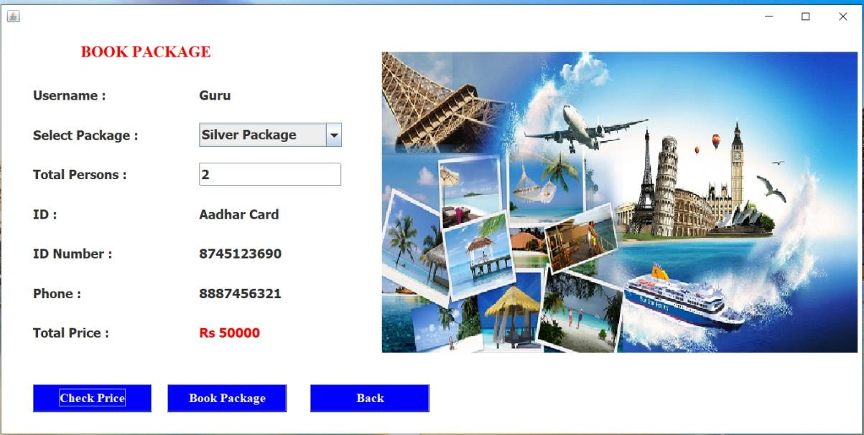

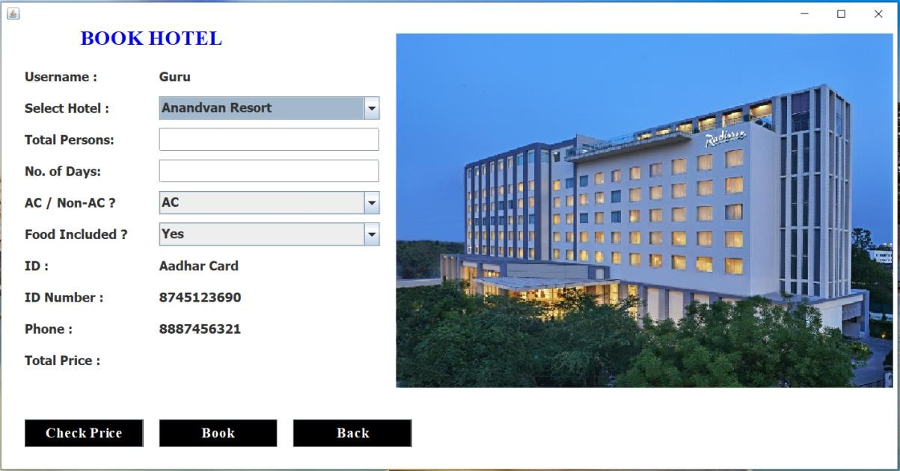**Book Hotel:**

**View Hotel:**

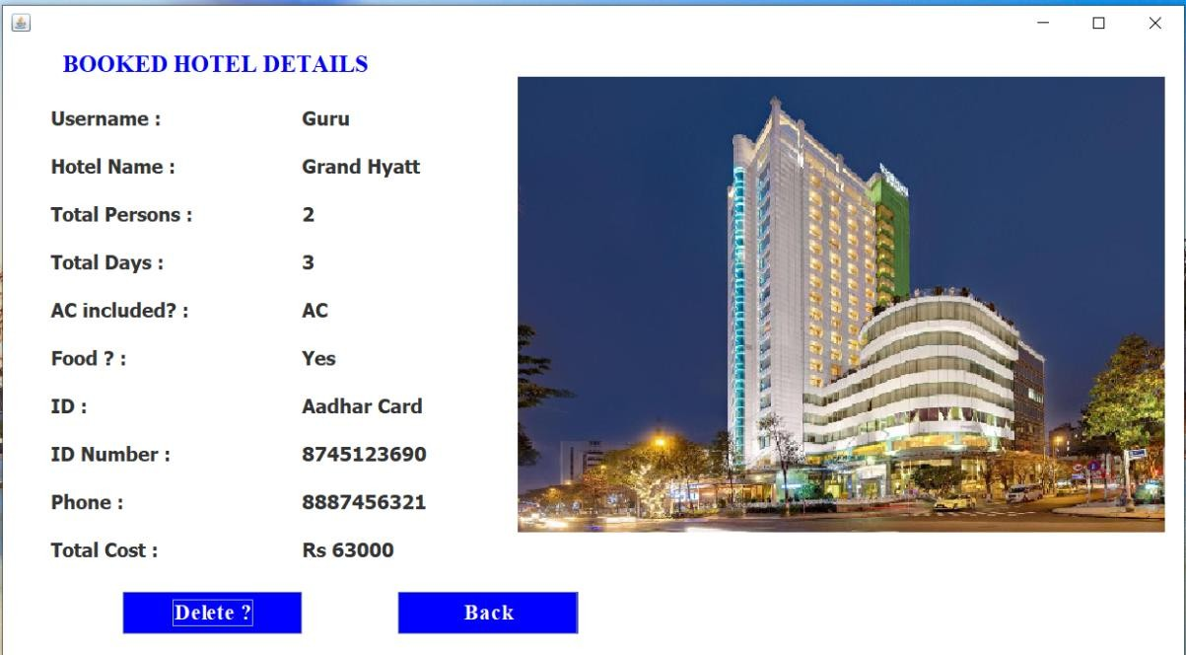

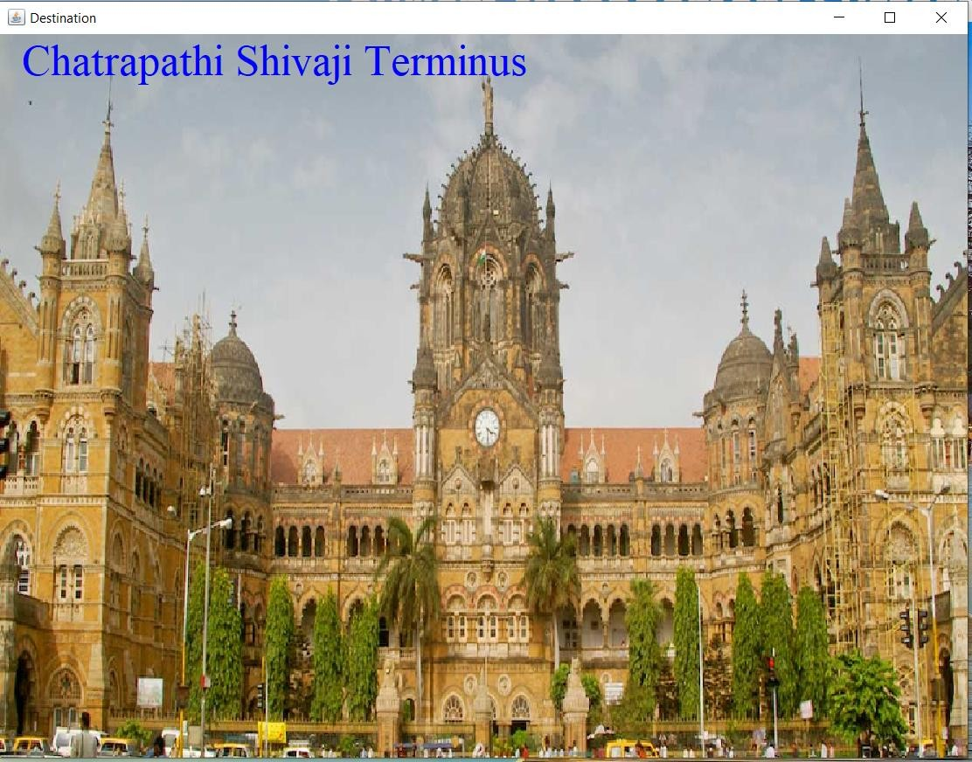**Destination Page:**

**Payment Page:**

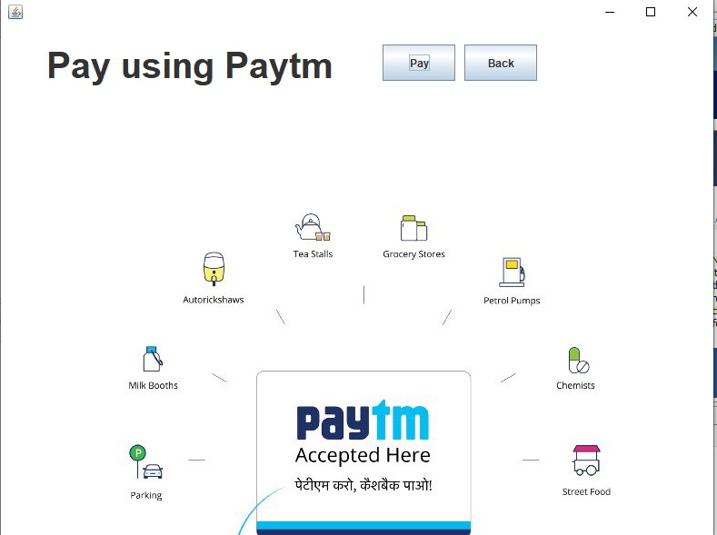

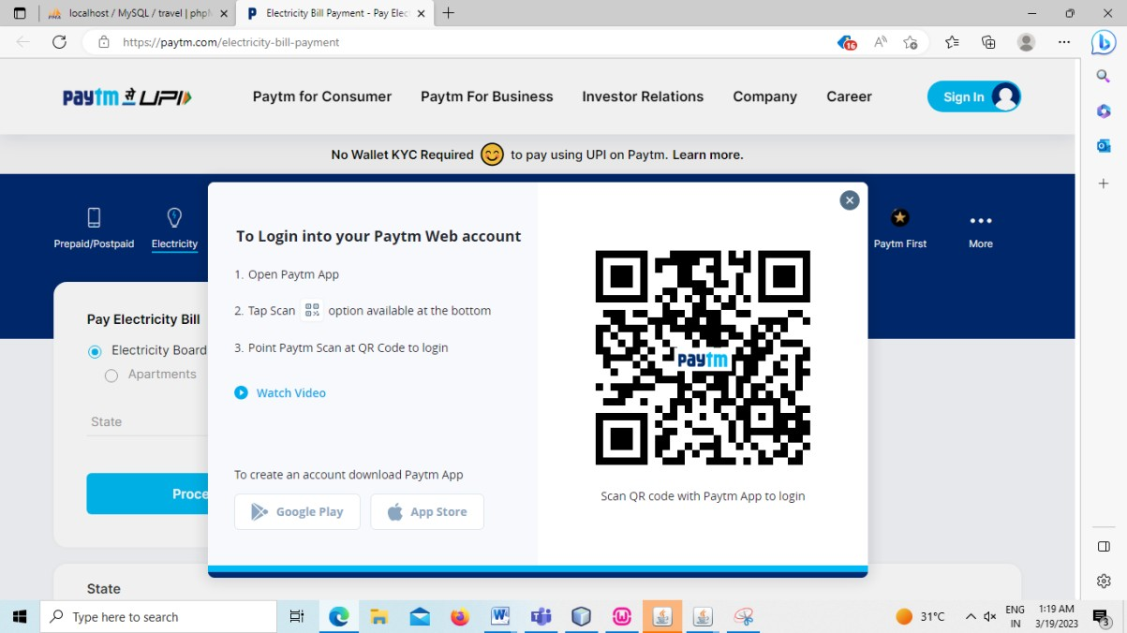

**Cash:**

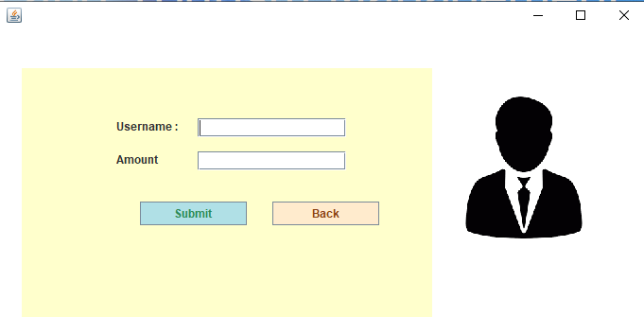

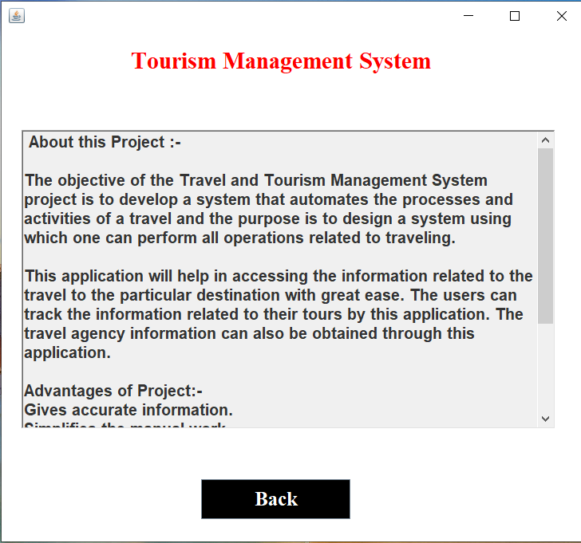**About Page:**

* 1. Sample Program Code

/*

* To change this license header, choose License Headers in Project Properties.
* To change this template file, choose Tools | Templates
* and open the template in the editor.

*/

package travel.management.system;

import java.awt.*; import javax.swing.*; import java.awt.event.*; import java.sql.*;

public class Login extends JFrame implements ActionListener{ private JPanel panel;

private JTextField textField;

private JPasswordField passwordField; private JButton b1,b2,b3;

public Login()

setBackground(new Color(255, 255, 204));

setBounds(550, 250, 700, 400);

panel = new JPanel(); panel.setBackground(Color.WHITE); setContentPane(panel); panel.setLayout(null);

JLabel l1 = new JLabel("Username : ");

l1.setBounds(124, 89, 95, 24); panel.add(l1);

JLabel l2 = new JLabel("Password : "); l2.setBounds(124, 124, 95, 24); panel.add(l2);

textField = new JTextField(); textField.setBounds(210, 93, 157, 20); panel.add(textField);

passwordField = new JPasswordField(); passwordField.setBounds(210, 128, 157, 20); panel.add(passwordField);

JLabel l3 = new JLabel(""); l3.setBounds(377, 79, 46, 34); panel.add(l3);

JLabel l4 = new JLabel(""); l4.setBounds(377, 124, 46, 34); panel.add(l3);

ImageIcon c1 = new ImageIcon(ClassLoader.getSystemResource("Travel/Management/System/icons/login.png"))

;

Image i1 = c1.getImage().getScaledInstance(150, 150,Image.SCALE_DEFAULT); ImageIcon i2 = new ImageIcon(i1);

JLabel l6 = new JLabel(i2); l6.setBounds(480, 70, 150, 150); add(l6);

b1 = new JButton("Login"); b1.addActionListener(this) b1.setForeground(new Color(46, 139, 87));

b1.setBackground(new Color(176, 224, 230));

b1.setBounds(149, 181, 113, 25); panel.add(b1);

b2 = new JButton("SignUp"); b2.addActionListener(this); b2.setForeground(new Color(139, 69, 19));

b2.setBackground(new Color(255, 235, 205));

b2.setBounds(289, 181, 113, 25); panel.add(b2);

b3 = new JButton("Forgot Password"); b3.addActionListener(this);

b3.setForeground(new Color(205, 92, 92));

b3.setBackground(new Color(253, 245, 230));

b3.setBounds(199, 231, 179, 25); panel.add(b3);

JLabel l5 = new JLabel("Trouble in Login?"); l5.setFont(new Font("Tahoma", Font.PLAIN, 15)); l5.setForeground(new Color(255, 0, 0));

l5.setBounds(70, 235, 110, 20); panel.add(l5);

JPanel panel2 = new JPanel(); panel2.setBackground(new Color(255, 255, 204));

panel2.setBounds(24, 40, 434, 263);

panel.add(panel2);

}

public void actionPerformed(ActionEvent ae){ if(ae.getSource() == b1){

Boolean status = false; try {

Conn con = new Conn();

String sql = "select * from account where username=? and password=?"; PreparedStatement st = con.c.prepareStatement(sql);

st.setString(1, textField.getText()); st.setString(2, passwordField.getText()); ResultSet rs = st.executeQuery();

if (rs.next()) { this.setVisible(false);

new Loading(textField.getText()).setVisible(true);

} else

JOptionPane.showMessageDialog(null, "Invalid Login or Password!")

} catch (Exception e2) { e2.printStackTrace(); }

}

if(ae.getSource() == b2){ setVisible(false);

Signup su = new Signup(); su.setVisible(true);

}

if(ae.getSource() == b3){

setVisible(false);

ForgotPassword forgot = new ForgotPassword(); forgot.setVisible(true);

}

}

public static void main(String[] args) { new Login().setVisible(true);

}

}

#### Limitations and Bibliography

We have taken references from many resources like YouTube and many websites and Books.

Books:

* + - Java and Integrated Approach by Nageswara Rao
    - Java Programming by Nirali Publication Websites:
    - [https://www.stackoverflow.com](https://www.stackoverflow.com/)
    - [https://www.javatpoint.com](https://www.javatpoint.com/)
    - [https://www.codecademy.com](https://www.codecademy.com/) YouTube video links:

1. <https://youtu.be/5vzCjvUwMXg>
2. <https://youtu.be/dwVj_g3TpZ4>
3. <https://youtu.be/L5RpqspNAuc>